
How to …
import pictures, audio and video in Serif DrawPlus X4

Optimize, optimize, optimize!

It is vital to understand that all media you add to your keyframe animation MUST be optimized before importing it into DrawPlus or any other animation program if you are to successfully manage file sizes and download times on the web. This is true whether for pictures, sound files or video. Serif’s schemes of work for Digital imaging, Creating graphics for the web and Creating video explain the necessary techniques in detail.

 | Insert pictures  In DrawPlus X4 open one of the practice animations you saved earlier, or start a new animation at a size of your choice. The example is a WebPlus10 Flash Banner preset size (700 pixels x 200 pixels).  It has 4 keyframes, with a frame rate of 750 milliseconds and a total running time of 3.0 seconds. The bitmap images of the dog were prepared and optimised in Serif PhotoPlus image editing software. TIFF and PNG formats work best and support transparency, as with the dog pictures. The image above, for example, is 34 KB in PNG format, but 194KB as a TIFF file. Which would you use?




 | 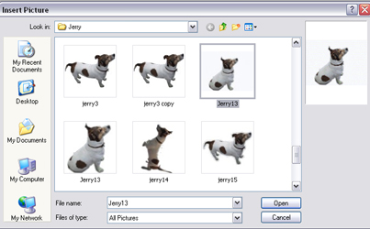  To import an image into your keyframe animation, click on the Insert Picture icon on the Drawing toolbar. Browse with the Insert Picture dialog to select an image you have saved – a photo, scan, vector drawing or other graphic – then click OK.  The dialog disappears and the mouse pointer changes to the Picture Size cursor. To insert the picture at a default size on the drawing frame, simply click the mouse. To set the size of the inserted picture, drag out a region and release the mouse button. The picture's aspect ratio is generally preserved. To allow free dragging to any aspect ratio, hold down the Shift key. To constrain the aspect ratio to a square, hold down the Ctrl key.

 | Insert audio  Audio adds another dimension to the visual impact of your keyframe animation.This could comprise spoken dialogue, a voiceover slogan, music (but be aware of copyright restrictions), or sound effects. You can record and edit your own audio, or search for copyright-free sounds on the internet. Your teacher may have a CD of sound effects too. Keep it short and sweet because sound files can be very large. Any editing should be done before importing the file into your animation.  Use a search engine and key in ‘free’, ‘WAV’ and MP3’. A useful web portal for finding free WAV audio files is: http://www.thefreesite.com/Free_Sounds/Free_WAVs/  You can edit WAV files very simply with Windows Sound Recorder, which you access via the Start > Programs menu: go to Accessories > Entertainment to locate it.    You can also download a free open source program called Audacity for recording and editing sounds in Windows, Linux, Mac OS X and other operating systems from: http://audacity.sourceforge.net/
 | The Storyboard tab for this banner advert indicates that the final two frames have sound files imported because the Sound icon is active (red rectangles). In the first frame the icon is greyed out (blue rectangle). | 
 | 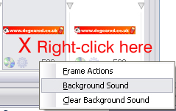  To add an audio clip, right-click on the keyframe and select Background Sound from the Insert menu. (Choose Clear Background Sound to remove any audio.)
 | 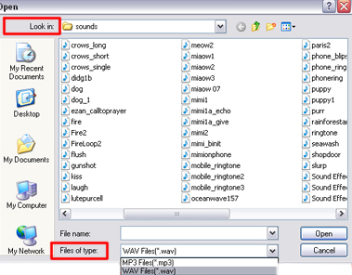  On the dialog window that opens, select either WAV files or MP3 files on the drop down Files of type menu and navigate to your audio file, select it and click Open.  Preview your work.  ‘Crowfield Vincent’ (see Media tab screenshot below) has four sound files: Birds (26 KB), Crow Chuckle (16 KB), Gunshot (5 KB) and Crows’ Echo (2513 KB). The longer WAV file added considerably to the file size of the exported SWF movie.
 | Managing media files  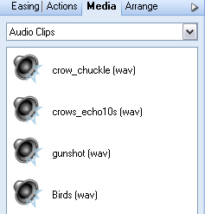  In DrawPlus any media files already imported into your animation can be managed from a central location on the Media tab, which allows viewing and direct replacement of media. The screenshot shows the four audio clips used in the ‘Crowfield Vincent’ animation.  The Media tab displays the media you have already inserted into your keyframe animation in different categories and with essential details: All Types, Bitmap images (shows file name, thumbnail and image dimensions), Movie Clips (shows duration), Audio Clips (file type) or Text Fragments (actual text). This makes identification and replacement easy. Right-click on a file and select Replace Media, then swap the file for another via the dialog that allows you to browse to the replacement.  Preview any changes and modify as necessary.
 | Insert video  As well as using sound in your keyframe animation, you can also introduce a movie clip. The video is inserted into a keyframe like any other object and needs to be run forward to play throughout the animation. DrawPlus X4 supports a variety of video formats e.g. Flash Video (FLV), Flash SWF, AVI, WMV< MPEG1, MPEG2 and QuickTime.
 | To add a movie clip, select a suitable keyframe and from the Insert menu, choose Movie Clip… Navigate to your prepared movie file using the dialog that appears and check that the correct file type has been selected in the Files of Type menu. Select your movie file and click Open.  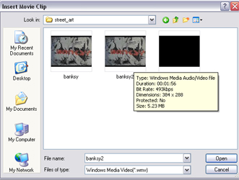  Position your cursor on the frame and click to insert the movie at its original size, or drag out a region and release the mouse button to set a different size.  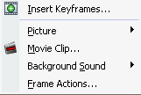
 | Use the Object Toolbar Controls to run the movie forward to the end of the animation.  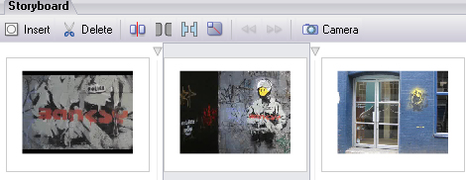
 | Preview any changes and modify as necessary. Save your work.

